Collision Avoidance Vehicle

**Project Description**:

The project is based on a vehicle that detects obstacles ahead of it and tries to avoid hitting them

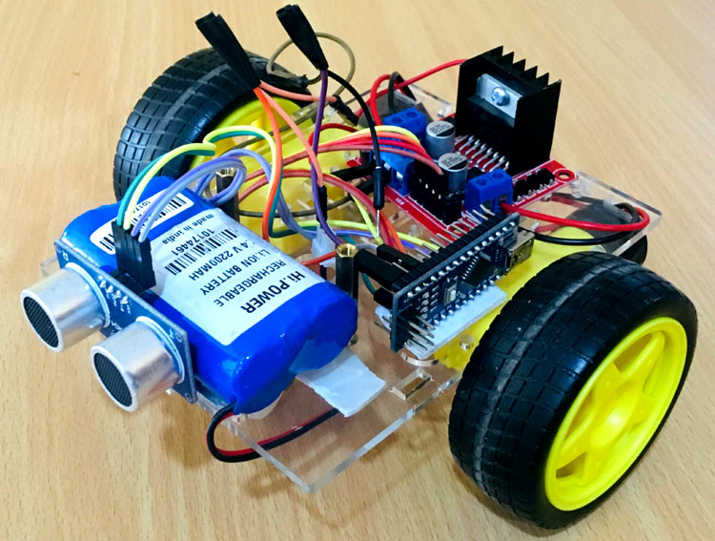

<https://circuitdigest.com/microcontroller-projects/arduino-obstacle-avoding-robot>

**Requirements**:

* The vehicle reads distance from ultrasonic sensor periodically
* Vehicle should take actions based on distance between the nearest obstacle
* If the distance is less than or equal the pre-defined threshold, the vehicle should stop
* If the distance is more than the pre-defined threshold, the vehicle should move

**Static Design:**

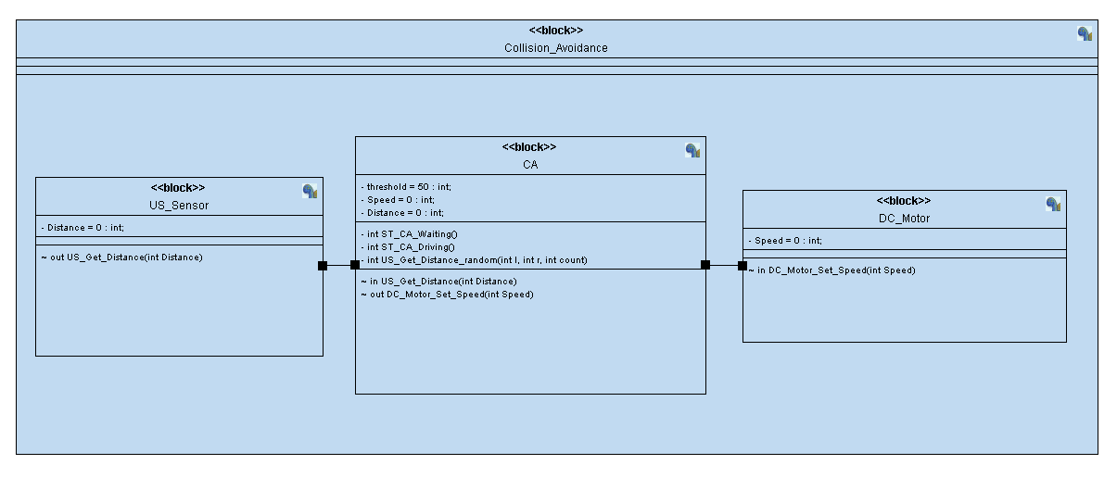

**Figure (1) Class Diagram**

**Dynamic Design:**

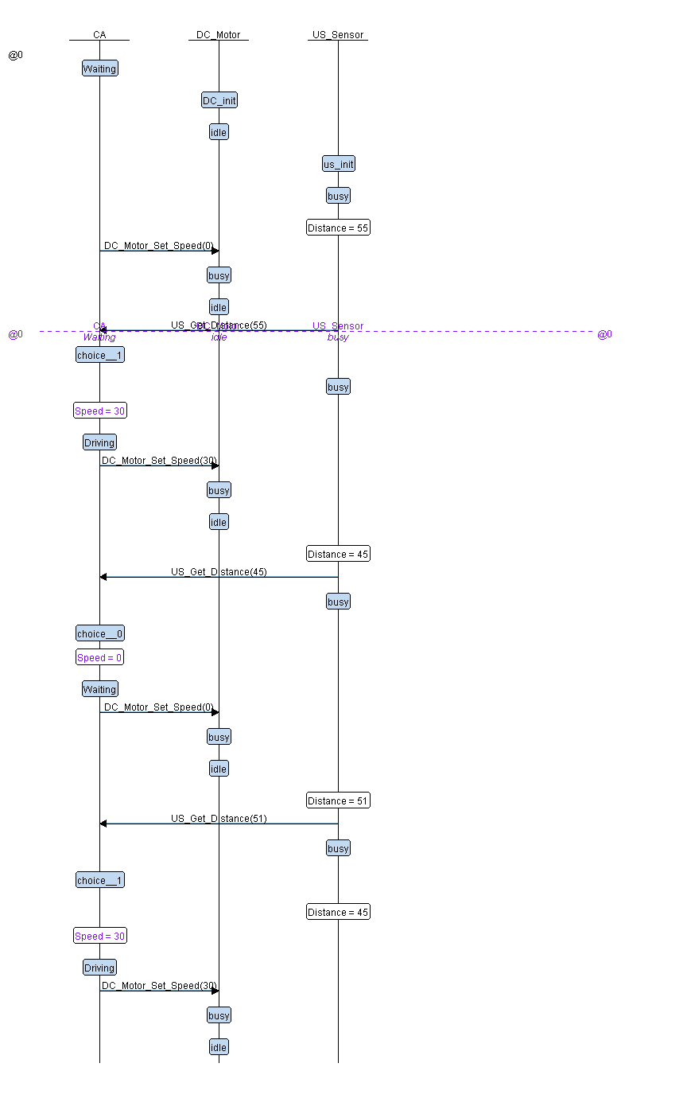

**Figure (2) Sequence Diagram**

**CA Block:**

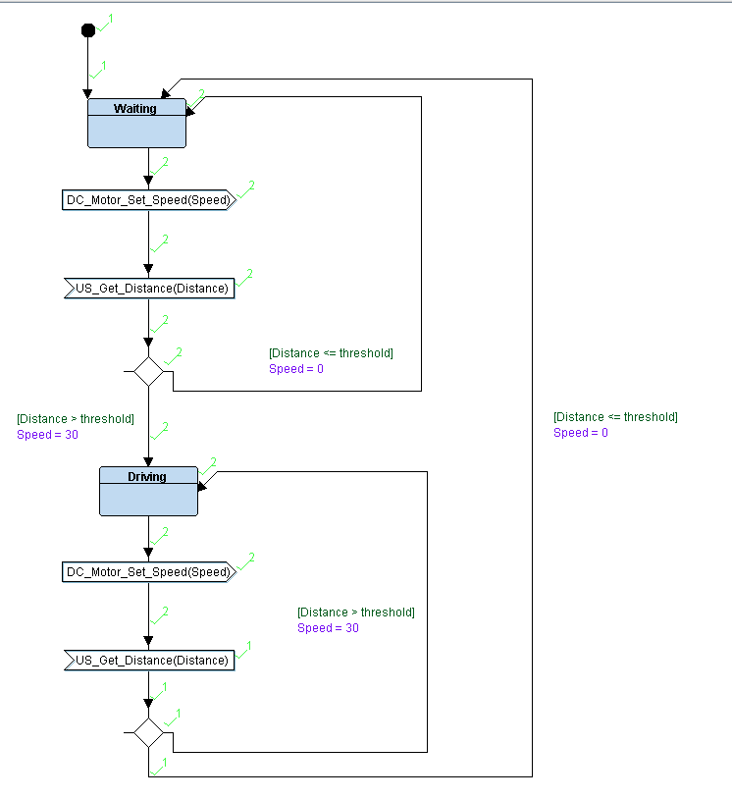

**Figure (3) CA State Diagram**

**DC_Motor Block:**

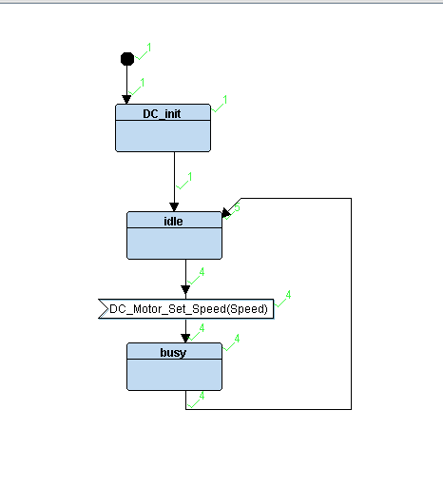

**Figure (4) DC_Motor State Diagram**

**US_Sensor Block:**

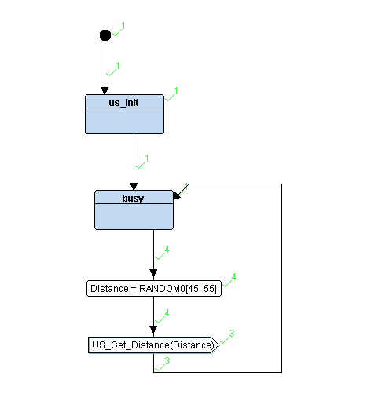

**Figure (5) US_Sensor State Diagram**